Overview of Physical Storage Media

- Several types of data storage exist in most computer systems. These storage media are classified by the capacity, the speed with which data can be accessed, by the cost per unit of data and by the medium and medium’s reliability.

1. Classification by capacity, speed and cost

- Cache: The cache most costly and fastest form of storage. Usually very small, volatile and managed by the computer system hardware.

- Main Memory: The storage medium used for data that are available to be operated on is the main memory.

- Fast access: 10 to 100 nanoseconds

- General-purpose machine instructions operate on main memory.

- Although main memory may contain many megabytes (or even gigabytes of data in large systems) of data, it is generally too small (or too expensive) to store the entire database.

-Contents of main memory are usually lost if a power failure or system crash occurs

- Flash memory:

- Data survive from power failure
- Data can be written at a location only once, but location can be erased and written again

    - Can support only a limited number (10K – 1M) of write/erase cycles.
    - Erasing of memory has to be done to an entire bank of memory

- Reads are roughly as fast as main memory (less than 100 nanoseconds) but writes are slow (4-10 microseconds), erase is slower

- Cost per unit of storage roughly similar to main memory

- Widely used in embedded devices such as digital cameras

- Is a type of EEPROM (Electrically Erasable Programmable Read-Only Memory)

- Magnetic-disk storage:

- Data is stored on spinning disk, and read/written magnetically

- Primary medium for long-term on-line storage of data; usually stores the entire database.

- Data must be moved from disk to main memory in order for the data to be operated on.

- After operations are performed, data must be copied back to disk if any changes were made.

- Direct access storage – it is possible to read data from any location on disk.

- Disk storage usually survives power failures and system crashes.

- The size of magnetic disks currently ranges from few GB to 400 GB. Growing constantly and rapidly with technology improvements (factor of 2 to 3 every 2 years)

- Optical storage:

- Non-volatile, data is read optically from a spinning disk using a laser

- Compact disk, CD-ROM (640 MB) and digital video disk, DVD (4.7 to 17 GB) most popular forms; cannot be written, but are supplied with data preloaded.

- Write-one, read-many (WORM) (“record once” version of CD)optical disks used for archival storage (CD-R, DVD-R, DVD+R)

- There are also “multiple-write” versions of compact disk (called CD-RW) and digital video disk (DVD-RW, DVD+RW and DVD-RAM), which can be written multiple times.

- Reads and writes are slower than with magnetic disk

- Juke-box systems, with large numbers of removable disks, a few drives, and a mechanism for automatic loading/unloading of disks available for storing large volumes of data

- Tape Storage: used primarily for backup and archival data.

- Non-volatile, cheaper, but much slower access, since tape must be read sequentially from the beginning.

- Used as protection from disk failures and large collection of data (remote sensing data from Satellite)

- Sequential access storage

- High capacity 40 to 300 GB

- Tape Jukeboxes [100s of terabyte (1TB = 10¹² bytes) or even pentabyte (10¹⁵ bytes)]

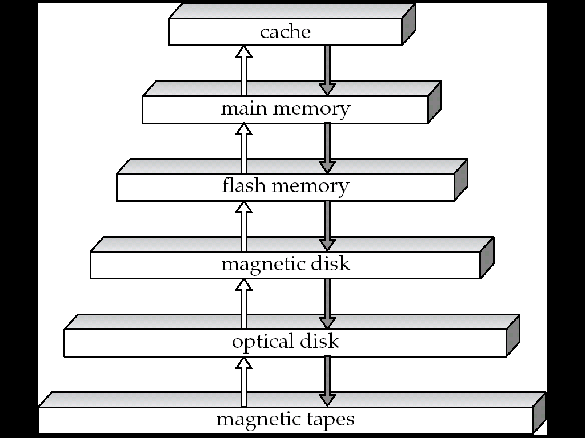

Storage-device Hierarchy

- Boxes indicate size
- The higher levels are expensive but fast
- Towards down the hierarchy the cost per bit decreases but access time increases
2. Classification by type of storage

- Primary storage: the fastest storage media, such as cache and main memory but volatile.

- Secondary (or on-line) storage: the next level of the hierarchy, e.g., flash memory, magnetic disks. Non-volatile and moderately fast access time.

- Tertiary (or offline) storage: magnetic tapes and optical disk juke boxes. Non-volatile and slow access time.

3. Classification by storage volatility

- Volatile storage: Volatile storage loses its contents when the power is removed. The storage systems from main memory up (cache, main memory) are volatile.

- Nonvolatile storage: The storage systems below main memory (flash memory, magnetic disk, optical disk, magnetic tape) are nonvolatile. Without power backup, data must be written to nonvolatile storage for safekeeping.

RAID Levels

RAID Level 0 (Striped Disk Array without Fault Tolerance)

RAID Level 0 requires a minimum of 2 drives to implement

Characteristics & Advantages

1. RAID 0 implements a striped disk array, the data is broken down into blocks and each block is written to a separate disk drive
2. I/O performance is greatly improved by spreading the I/O load across many channels and drives

3. Best performance is achieved when data is striped across multiple controllers with only one drive per controller
4. No parity calculation overhead is involved
5. Very simple design
6. Easy to implement
Disadvantages

1. Not a "True" RAID because it is NOT fault-tolerant
2. The failure of just one drive will result in all data in an array being lost
3. Should never be used in mission critical environments
Recommended Applications
• Video Production and Editing
• Image Editing
• Pre-Press Applications
• Any application requiring high bandwidth

RAID Level 1 (Mirroring & Duplexing)

1. For Highest performance, the controller must be able to perform two concurrent separate Reads per mirrored pair or two duplicate Writes per mirrored pair.
2. RAID Level 1 requires a minimum of 2 drives to implement
Characteristics & Advantages

1. One Write or two Reads possible per mirrored pair
2. Twice the Read transaction rate of single disks, same Write transaction rate as single disks
3. 100% redundancy of data means no rebuild is necessary in case of a disk failure, just a copy to the replacement disk
4. Transfer rate per block is equal to that of a single disk
5. Under certain circumstances, RAID 1 can sustain multiple simultaneous drive failures
6. Simplest RAID storage subsystem design
Disadvantages

1. Highest disk overhead of all RAID types (100%) - inefficient
2. Typically the RAID function is done by system software, loading the CPU/Server and possibly degrading throughput at high activity levels. Hardware implementation is strongly recommended
3. May not support hot swap of failed disk when implemented in "software"
Recommended Applications
• Accounting
• Payroll
• Financial
• Any application requiring very high availability

2. Controller design is fairly complex

Indexing

- Many queries reference only a small fraction of records in a file. For example, “find all accounts at Mirpur branch” only returns records from account file where branch_name = “Mirpur". It is inefficient for the system to read every record and to check the branch_name field for the name “Mirpur”.

- We should be able to locate these records directly. To allow these forms of access, we design additional structures associated with files.

Dense and Sparse Indices

- An index record or index entry, consists of a search-key value and pointers to one or more records with that value as their search key value. The pointer to a record consists of the identifier of a disk block and an offset within the disk block to identify the record within the block.

- There are Two types of ordered indices:

1. Dense Index:

_ An index record appears for every search key value in the file.

_ The index record contains the search key value and a pointer to the first data record with that search key value. The rest of the records with the same search key value would be sorted sequentially after the first records. This is because the index is a primary index; records are sorted on same search key.

_ Dense index implementation may store a list of pointers to all records with the same search key value; doing so is not essential for primary indices.

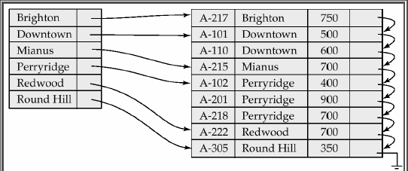

Figure: 12.2 Dense Index

2. Sparse Index:

_ An Index record appears for only some of the search-key values.

_ As is true in dense indices, the index record contains the search key value and a pointer to the first data record with that search key value.

_ To locate a record, we find the index record with the largest search key value less than or equal to the search key value we are looking for.

_ We start at that record pointed to by the index record, and proceed along the pointers in the file (that is, sequentially) until we find the desired record.

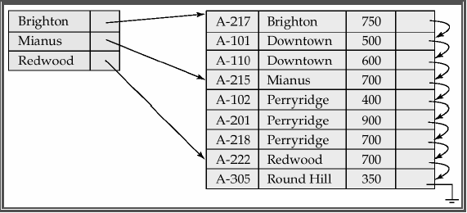

Figure 12.3 Sparse Index

- Dense indices are faster to locate a record in general, but sparse indices require less space and impose less maintenance for insertions and deletions.

- Good Trade-off: There is trade-off that the system designer must make between access time and space overhead. Although the decision depends on the specific application, a good compromise is to have a sparse index with an index entry for every block in file, corresponding to least search key value in the block.

Why is this good?

_ The dominant cost in processing a database request is the time it takes to bring a block from disk into main memory.

_ Using this sparse index, we locate block containing the record we are seeking.

_ Unless the record is on an overflow block (actually could be several blocks), we minimizes block accesses while keeping the index size as small as possible.

12.2.2 Multi-Level Indices

- Even with a sparse index, index size may still grow too large. For 100,000 records, 10 per block, at one index record per block, that's 10,000 index records! Since index records are smaller than data records, if we can fit 100 index records per block, this index occupies 100 blocks.

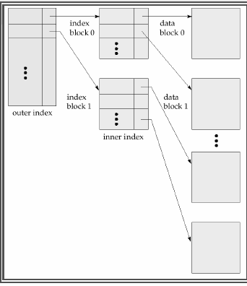

Two level sparse index

- If index is too large to be kept in main memory, a search results in several disk reads.

_ If there are no overflow blocks in the index, we can use binary search.

_ If there are b blocks, this will read as many as log₂(b) blocks (as many as 7 for our 100 blocks).

_ If index has overflow blocks, then sequential search is typically used, reading all b index blocks.

